Assignment 7
Name:-Yadnesh Patil
PRN:-123B1D034
Assignment 7 : Implement SQL queries to demonstrate the nested queries in SQL using MySql.
CREATE DATABASE ASSIGNMENT_7_Nested;
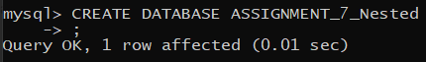
USE ASSIGNMENT_7_Nested;
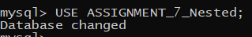
Creating Tables and Inserting Values into it:
1). Departments:
CREATE TABLE Departments (DepartmentID INT PRIMARY KEY AUTO_INCREMENT, DeptName VARCHAR(100) UNIQUE NOT NULL, HOD VARCHAR(100) NOT NULL);
mysql> INSERT INTO Departments (DeptName, HOD) VALUES
-> ('Computer Sci', 'Dr. Sharma'),
-> ('Electronics', 'Dr. Ramesh'),
-> ('Computer Regional', 'Dr. Patil'),
-> ('Mechanical', 'Dr. Dube'),
-> ('Civil', 'Dr. Joshi');
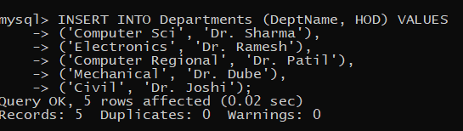
SELECT * FROM Departments;
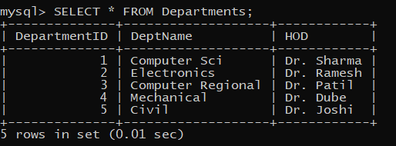
1). Students:
CREATE TABLE Students (StudentID INT PRIMARY KEY AUTO_INCREMENT, Name VARCHAR(100) NOT NULL, DepartmentID INT, CGPA DECIMAL(3,2) CHECK (CGPA BETWEEN 0 AND 10), FOREIGN KEY (DepartmentID) REFERENCES Departments(DepartmentID) ON DELETE SET NULL);
mysql> INSERT INTO Students (Name, DepartmentID, CGPA) VALUES
-> ('Atharva Zope', 3, 9.5),
-> ('Adwait Kamble', 3, 8.7),
-> ('Devraj Bafna', 1, 9.2),
-> ('Advait Nathe', 2, 8.0),
-> ('Pratiksha Hazare', 4, 8.5),
-> ('Vishwajeet Bhamre', 4, 7.9),
-> ('Pooja Desai', 5, 8.9),
-> ('Vikas Singh', 5, 7.0); 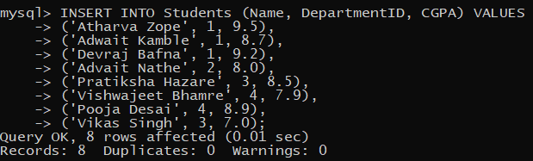

SELECT * FROM Students;
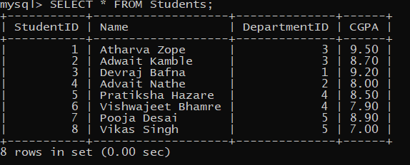

3). Courses:
CREATE TABLE Courses (CourseID VARCHAR(10) PRIMARY KEY, CourseName VARCHAR(100) NOT NULL, DepartmentID INT, FOREIGN KEY (DepartmentID) REFERENCES Departments(DepartmentID) ON DELETE CASCADE);
mysql> INSERT INTO Courses (CourseID, CourseName, DepartmentID) VALUES
-> ('CSE101', 'Data Structures', 1),
-> ('CSE102', 'Algorithms', 1),
-> ('CSR101', 'Object-Oriented Programming', 3),
-> ('CSR102', 'Database Management Systems', 3),
-> ('CSE103', 'Advanced Data Structures', 3),
-> ('ECE201', 'Analog Circuits', 2),
-> ('ECE202', 'Digital Logic', 2),
-> ('MECH302', 'Fluid Mechanics', 3),
-> ('MECH301', 'Thermodynamics', 3),
-> ('CIV401', 'Structural Engineering', 5),
-> ('CIV402', 'Transportation Engg', 5);

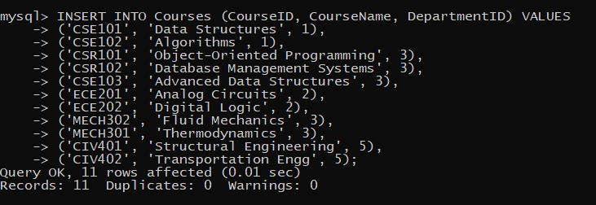
SELECT * FROM Courses;
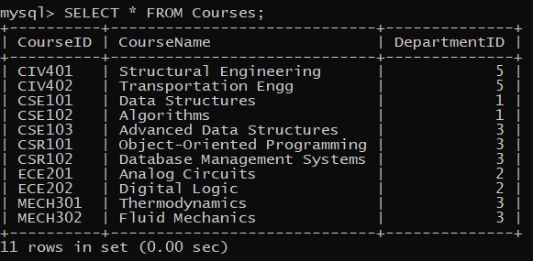
4). Enrollments:
CREATE TABLE Enrollments (EnrollmentID INT PRIMARY KEY AUTO_INCREMENT, StudentID INT, CourseID VARCHAR(10), Marks INT CHECK (Marks BETWEEN 0 AND 100), FOREIGN KEY (StudentID) REFERENCES Students(StudentID), FOREIGN KEY (CourseID) REFERENCES Courses(CourseID), UNIQUE (StudentID, CourseID));

select * from Enrollments;
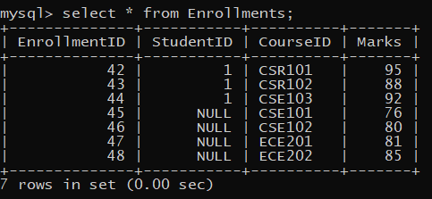

Solve following SQL Queries:

1. Find students who have a CGPA higher than the university average CGPA.
SELECT * FROM Students WHERE CGPA > (SELECT AVG(CGPA) FROM Students);
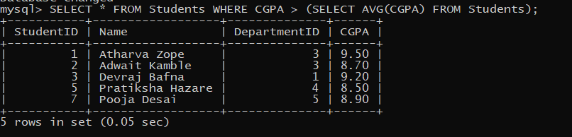

2. Find students who have never enrolled in any course
SELECT * FROM Students WHERE StudentID NOT IN (SELECT DISTINCT StudentID FROM Enrollments);

3. Get courses that have no students enrolled
SELECT * FROM Courses WHERE CourseID NOT IN (SELECT DISTINCT CourseID FROM Enrollments);
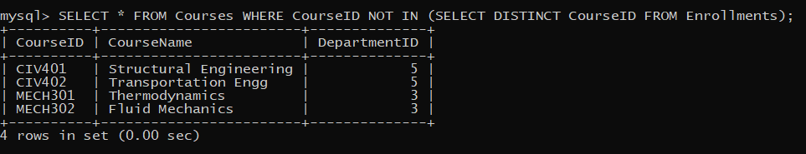

4. Get students enrolled in courses offered by the 'Computer Sci' department
SELECT StudentID FROM Students WHERE StudentID NOT IN (SELECT DISTINCT StudentID FROM Enrollments);

ALTER TABLE Students ADD COLUMN Age INT CHECK (Age >= 18);
Query OK, 8 rows affected (0.17 sec)
Records: 8 Duplicates: 0 Warnings: 0
5. Find students who have the same age as the oldest student
SELECT * FROM Students WHERE Age = (SELECT MAX(Age) FROM Students);
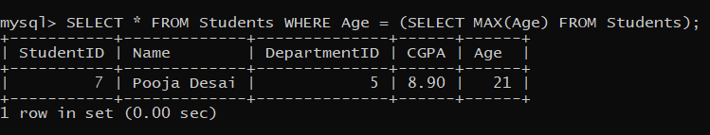

6. Retrieve courses where at least one student scored more than 85 marks.
SELECT DISTINCT C.* FROM Courses C JOIN Enrollments E ON C.CourseID = E.CourseID WHERE E.Marks > 85;
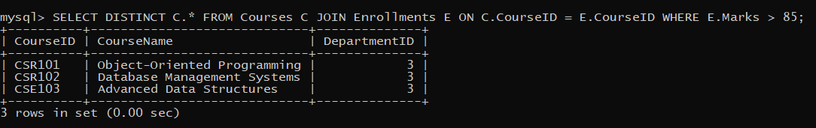

7. Find the highest CGPA in each department
SELECT DepartmentID, MAX(CGPA) AS HighestCGPA FROM Students GROUP BY DepartmentID;
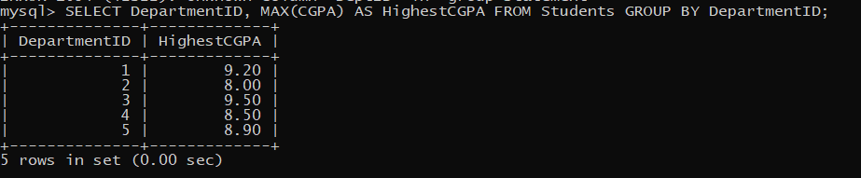

8. Get students who have enrolled in more than one course
SELECT StudentID FROM Enrollments GROUP BY StudentID HAVING COUNT(DISTINCT CourseID) > 1;
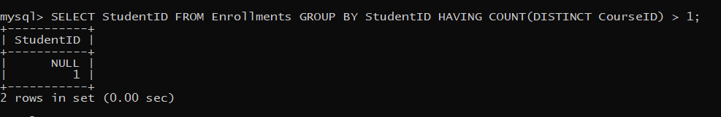

9. Get the department with the most students enrolled
SELECT DepartmentID FROM Students GROUP BY DepartmentID ORDER BY COUNT(StudentID) DESC LIMIT 1;
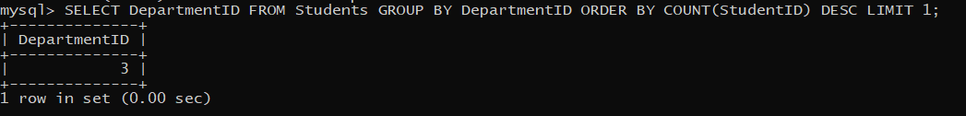

10. Find students who are not enrolled in any course
SELECT * FROM Students WHERE StudentID NOT IN (SELECT DISTINCT StudentID FROM Enrollments);

11. Retrieve students who scored below the average marks in their courses
SELECT S.* FROM Students S JOIN Enrollments E ON S.StudentID = E.StudentID WHERE E.Marks < (SELECT AVG(Marks) FROM Enrollments WHERE CourseID = E.CourseID);
12. Find the department where the highest CGPA student belongs
SELECT DepartmentID FROM Students WHERE CGPA = (SELECT MAX(CGPA) FROM Students);
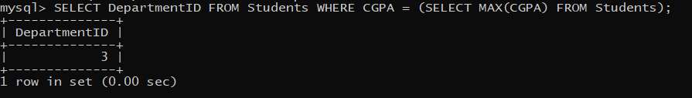

13. Find the department with the highest number of students enrolled
SELECT DepartmentID FROM Students GROUP BY DepartmentID ORDER BY COUNT(StudentID) DESC LIMIT 1;
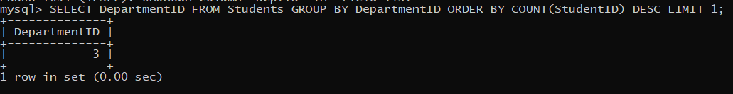

14. Get courses where the lowest score is higher than 70
SELECT CourseID FROM Enrollments GROUP BY CourseID HAVING MIN(Marks) > 70;
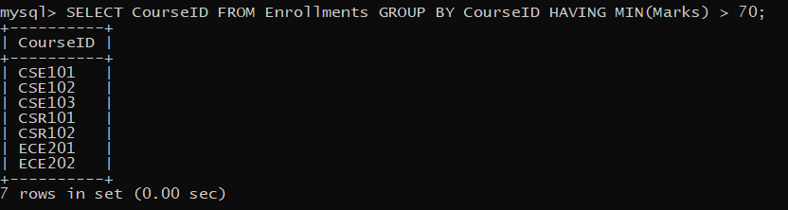

15. Retrieve students who have the same CGPA as 'Alice'
SELECT * FROM Students WHERE CGPA = (SELECT CGPA FROM Students WHERE Name = 'Alice');

16. Get the course where the maximum number of students have enrolled
SELECT CourseID FROM Enrollments GROUP BY CourseID ORDER BY COUNT(StudentID) DESC LIMIT 1;
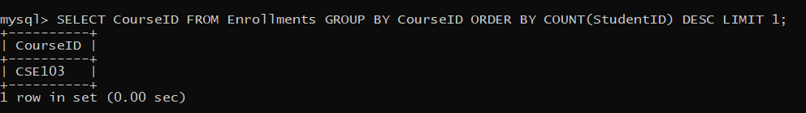

17. Find students who are enrolled in more than two courses
SELECT StudentID FROM Enrollments GROUP BY StudentID HAVING COUNT(DISTINCT CourseID) > 2;
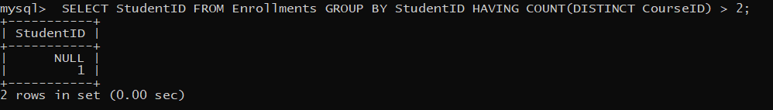

18. Retrieve students who have scored the highest marks in any course(Hint: Use Join along with nested quesries).
SELECT S.* FROM Students S JOIN Enrollments E ON S.StudentID = E.StudentID WHERE E.Marks = (SELECT MAX(Marks) FROM Enrollments WHERE CourseID = E.CourseID);
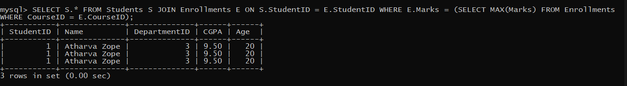

19. Get the department with the lowest average CGPA
SELECT DepartmentID FROM Students GROUP BY DepartmentID ORDER BY AVG(CGPA) ASC LIMIT 1;
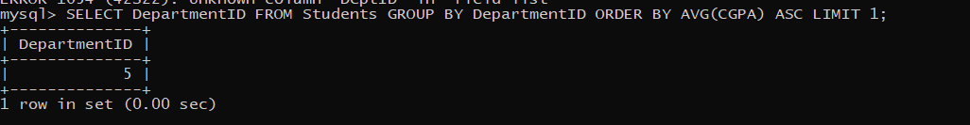

20. Find the course in which the maximum number of students have failed (Marks < 40)
SELECT CourseID FROM Enrollments WHERE Marks < 40 GROUP BY CourseID ORDER BY COUNT(StudentID) DESC LIMIT 1;
**************************************************************************************************************************************

